**Guided Capstone Project Report**

**Introduction**

Big Mountain Resort is a ski resort located in Montana, with access to 105 trails. Every year about 350,000 people ski or snowboard at Big Mountain. This mountain can accommodate skiers and riders of all levels and abilities. Big Mountain Resort recently installed an additional chair lift which causes an operating cost increase of $1,540,000 this season.

The business wants some guidance on how to select a better value for the ticket price. After doing the EDA analysis and training the random forest models on the dataset, we have drawn up several scenarios for cutting the cost or increasing the revenue.

**Big Mountain Resort (BMR) in Market Context**

The current adult weekend ticket price of BMR is $81. From the following histogram plot, we can conclude that the ticket price of BMR is mid-range compared to the market context, but it is the most expensive in the state of Montana.

**Fig.1**  **Fig.2**

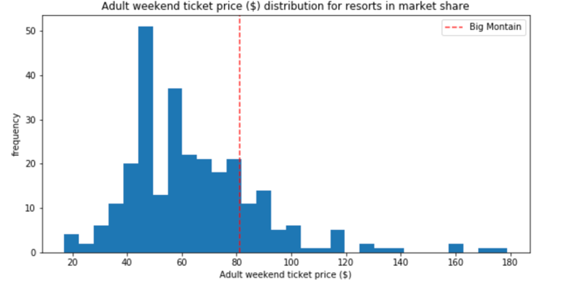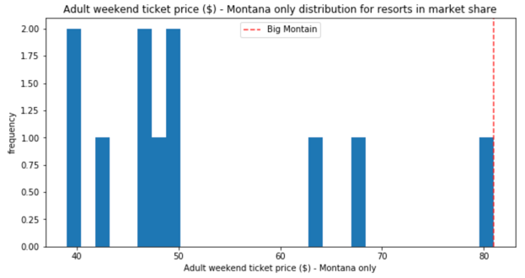

The following features come up as necessary in the modeling:

* The vertical drop in BMR is 2353ft, which is doing well compared to other resorts, but there are still quite a few resorts with a more significant drop.
* Big Mountain is very high up the snow-making area's league table and has amongst the highest number of total chairs, regardless of the outlier.
* Most resorts have no fast quads. Big Mountain has 3, which puts it high up that league table.
* It also compares well for the number of runs. Big Mountain has one of the longest runs.
* Although it is just over half the length of the longest, the longer ones are rare.
* Big Mountain is amongst the resorts with the largest amount of skiable terrain.

**Modeling Scenarios**

We trained the random forest model on the dataset and got the modeled price of $94.22, with the expected mean absolute error of $10.39. This result indicates the ticket price of BMR is underestimate.

In the following scenario analysis, the expected number of visitors over the season is 350,000, and on average, visitors ski for five days. Assume the provided data includes the additional lift that Big Mountain recently installed.

**Scenario1: Close up to 10 of the least used runs.**

The model shows closing one run will not affect the revenue. The revenue will decrease by $2,250,000 if they close 6 to 8 runs and be reduced by $3,000,000 if they close 9 to 10 runs.

**Fig.3**

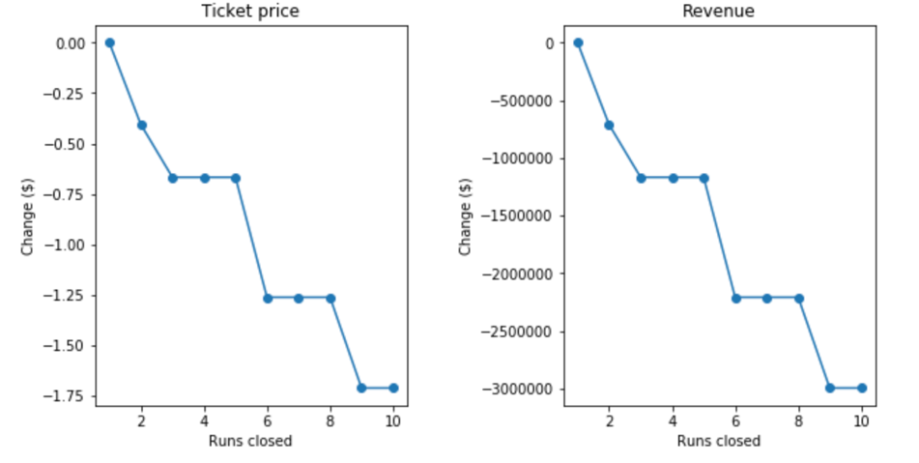

Scenario2: Adding a run, increasing the vertical drop by 150 feet, and installing an additional chair lift.

By adding these extra supports, the ticket price increase by $1.99, which equivalent to an annual revenue increase of $3,474,638. This amount can easily cover the operating cost of installing an additional chair lift. If we keep the original conditions in scenario two but add 2 acres of snow-making, the result makes no difference.

Scenario3: calls for increasing the longest run by .2 miles and guaranteeing its snow coverage by adding 4 acres of snow-making capability.

This scenario doesn't change the ticket price and annual revenue at all.